**Modul 3**

Nama : Andrias Sigid W.R

NIM : L200144010

Percobaan 1

No.3

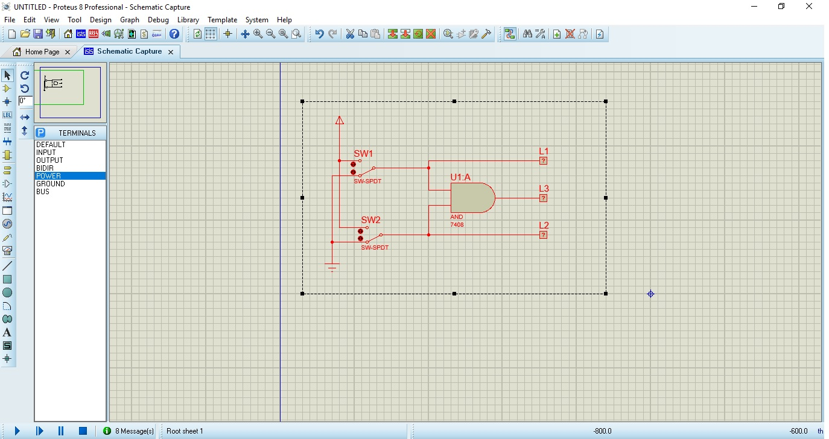

|  |  |  |  |  |
| --- | --- | --- | --- | --- |
| **SW1** | **SW2** | **L1** | **L2** | **L3** |
| 0 | 0 | 0 | 0 | 0 |
| 1 | 0 | 1 | 0 | 0 |
| 0 | 1 | 0 | 0 | 1 |
| 1 | 1 | 1 | 1 | 1 |

Percobaan 2

No.3

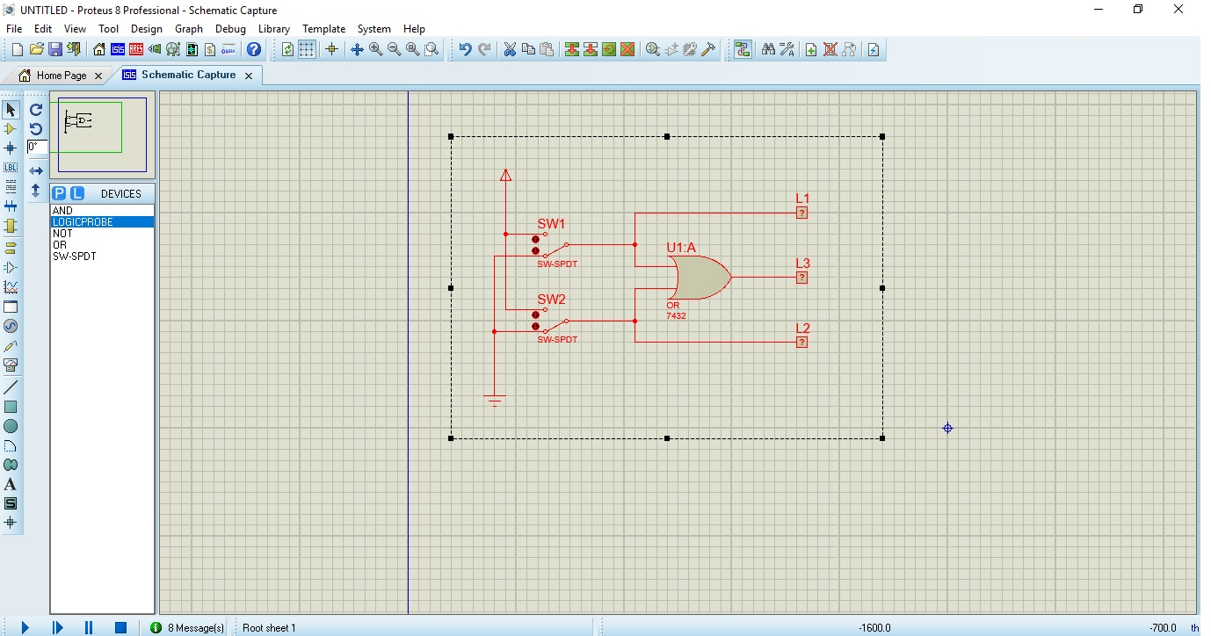

|  |  |  |  |  |
| --- | --- | --- | --- | --- |
| SW1 | SW2 | L1 | L2 | L3 |
| 0 | 0 | 0 | 0 | 0 |
| 1 | 0 | 1 | 0 | 1 |
| 0 | 1 | 0 | 1 | 1 |
| 1 | 1 | 1 | 1 | 1 |

Percobaan 3

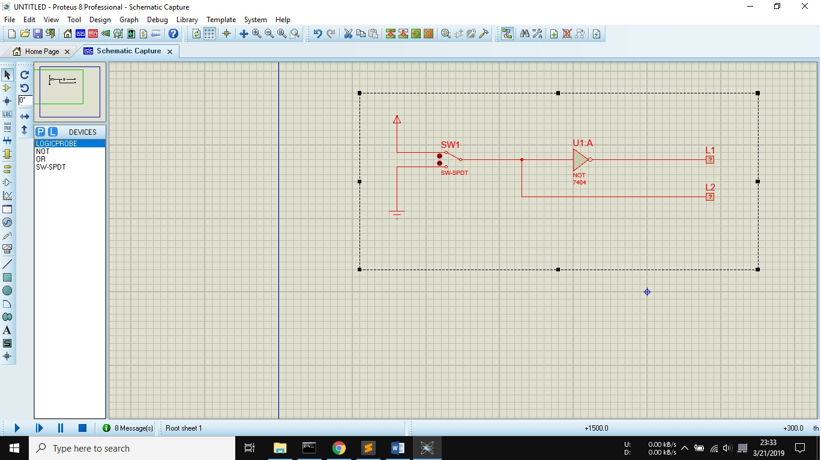

|  |  |  |
| --- | --- | --- |
| SW1 | L2 | L1 |
| 0 | 0 | 1 |
| 1 | 1 | 0 |

Percobaan 4

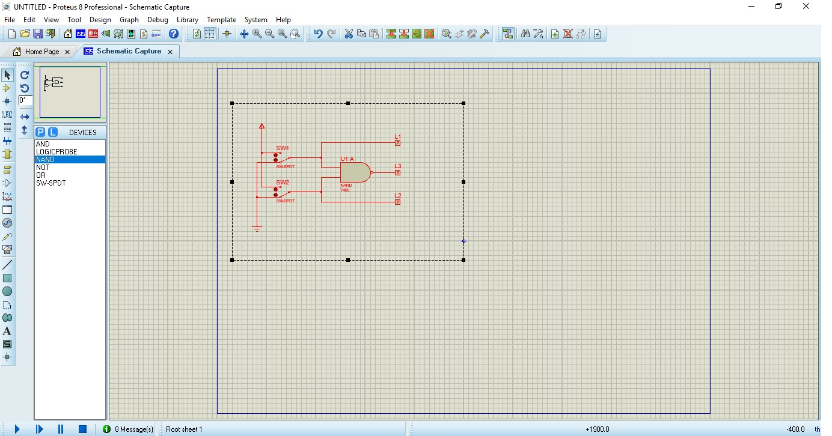

|  |  |  |  |  |
| --- | --- | --- | --- | --- |
| SW1 | SW2 | L1 | L2 | L3 |
| 0 | 0 | 0 | 0 | 1 |
| 1 | 0 | 1 | 0 | 1 |
| 0 | 1 | 0 | 1 | 1 |
| 1 | 1 | 1 | 1 | 0 |

Percobaan 5

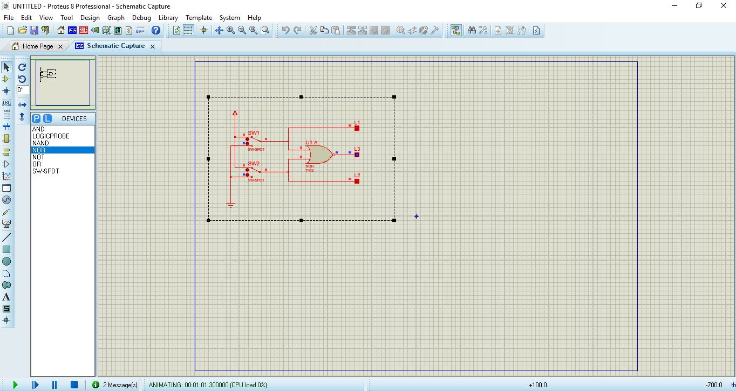

|  |  |  |  |  |
| --- | --- | --- | --- | --- |
| SW1 | SW2 | L1 | L2 | L3 |
| 0 | 0 | 0 | 0 | 1 |
| 1 | 0 | 1 | 0 | 0 |
| 0 | 1 | 0 | 1 | 0 |
| 1 | 1 | 1 | 1 | 0 |

Percobaan 6

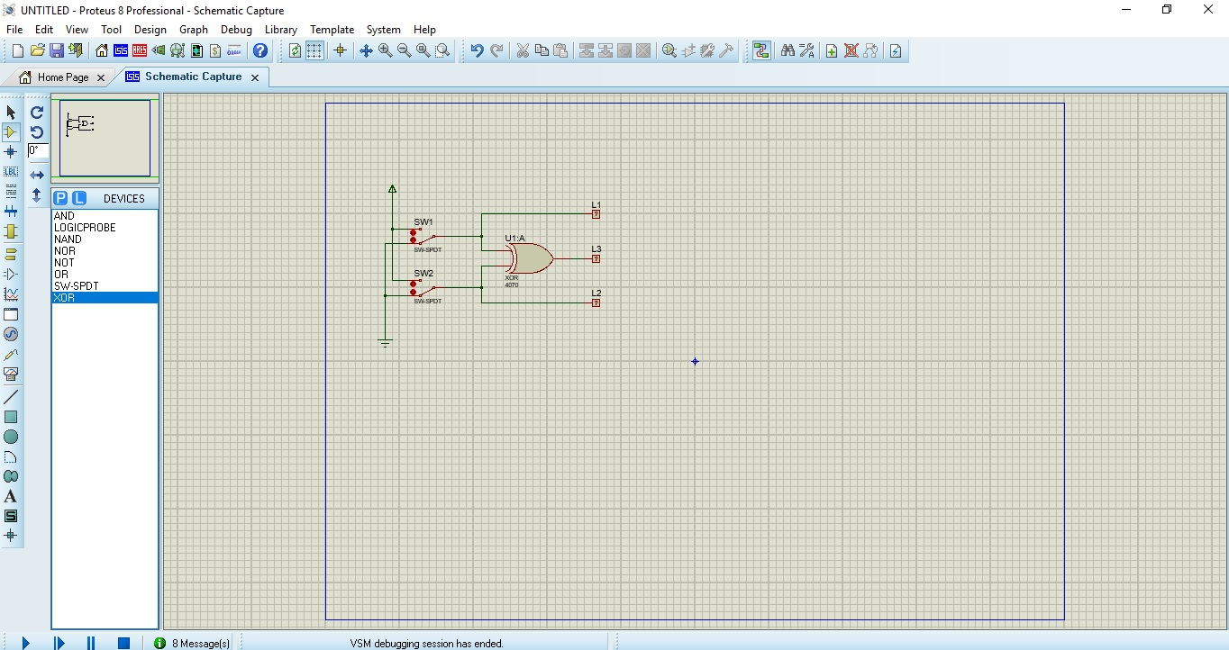

|  |  |  |  |  |
| --- | --- | --- | --- | --- |
| SW1 | SW2 | L1 | L2 | L3 |
| 0 | 0 | 0 | 0 | 0 |
| 1 | 0 | 1 | 0 | 1 |
| 0 | 1 | 0 | 1 | 1 |
| 1 | 1 | 1 | 1 | 0 |

Percobaan 7

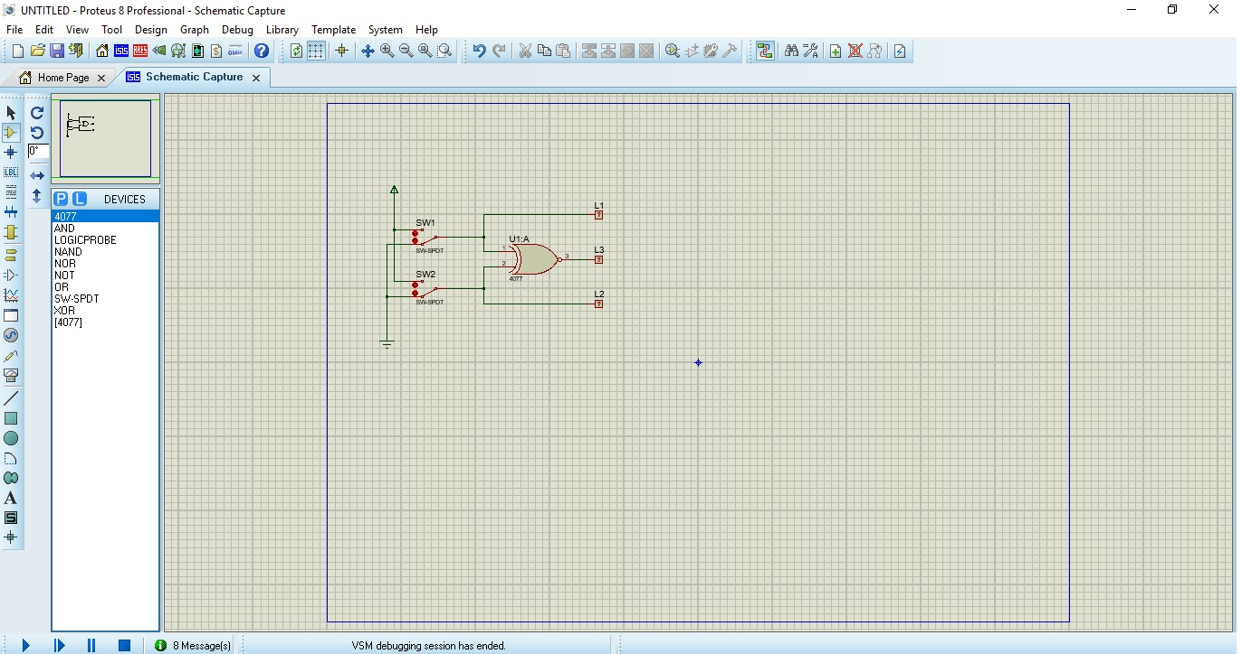

|  |  |  |  |  |
| --- | --- | --- | --- | --- |
| SW1 | SW2 | L1 | L2 | L3 |
| 0 | 0 | 0 | 0 | 1 |
| 1 | 0 | 1 | 0 | 0 |
| 0 | 1 | 1 | 0 | 1 |
| 1 | 1 | 1 | 1 | 1 |